**● Explain and perform Sqoop Incremental Import operation to load data from Mysql To HDFS using Sqoop**

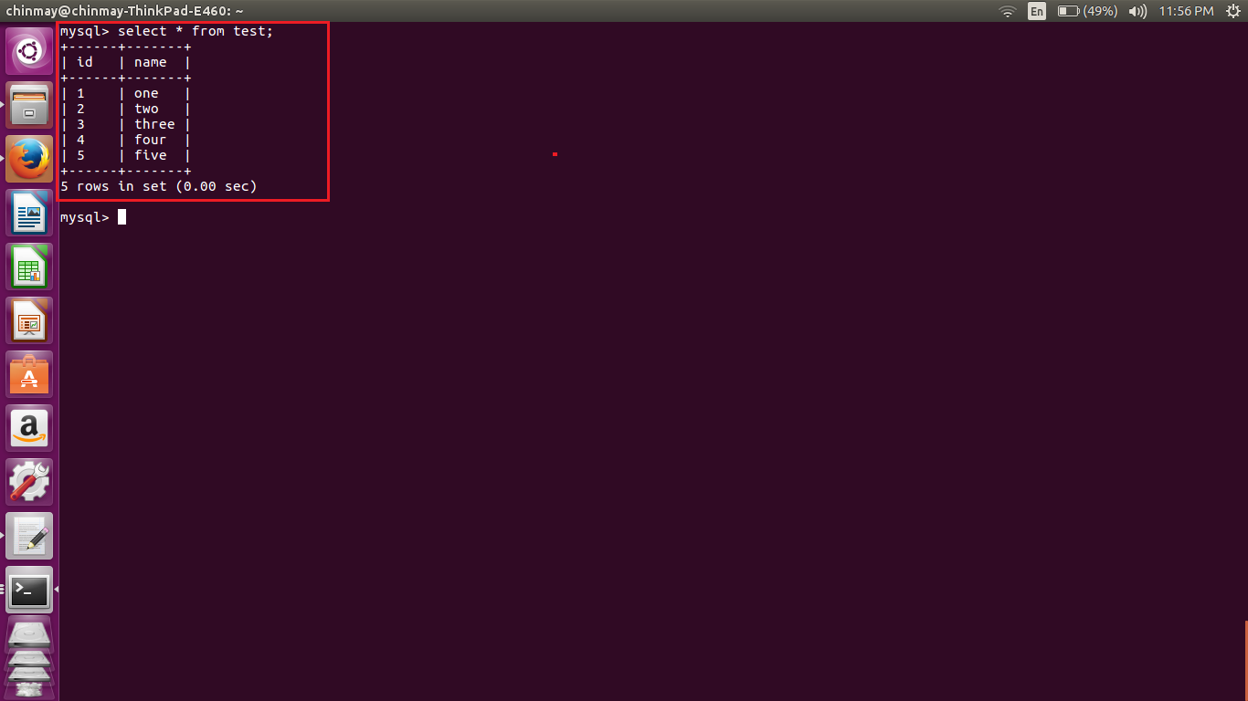

**We can see that a table with 5 values are created.**

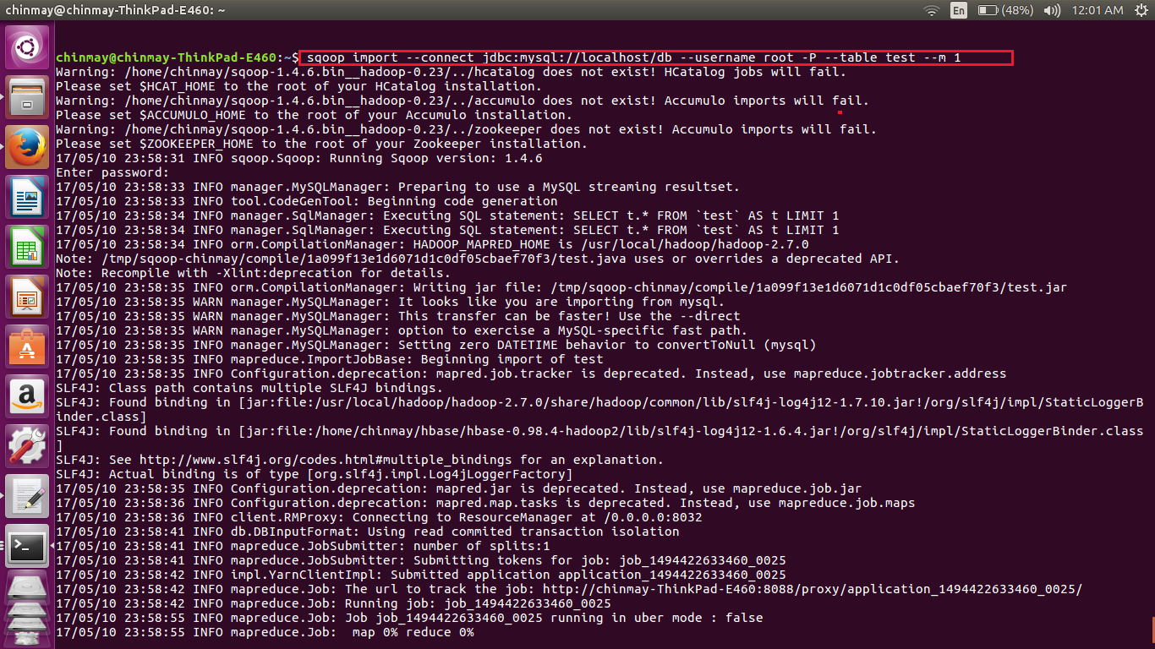

**In the above table we have executed the scoop command to store the table into the hdfs. We have mentioned the database name and the table name in the command.**

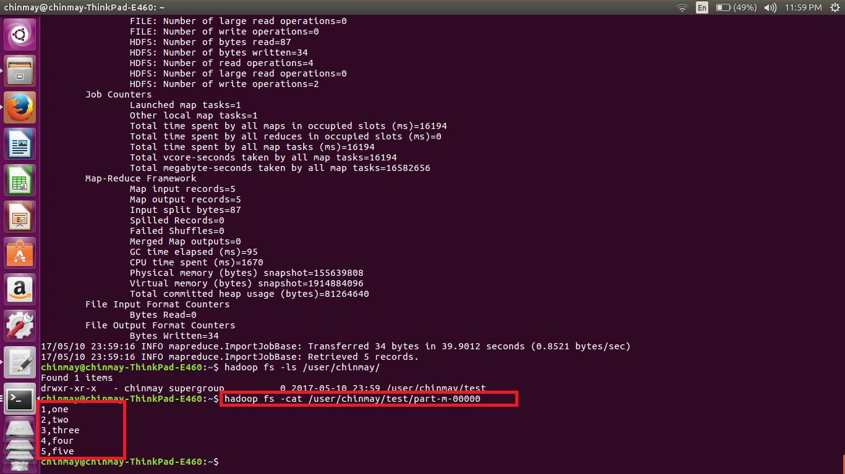

**Here we can see that the values are added into the hdfs as comma separated values.**

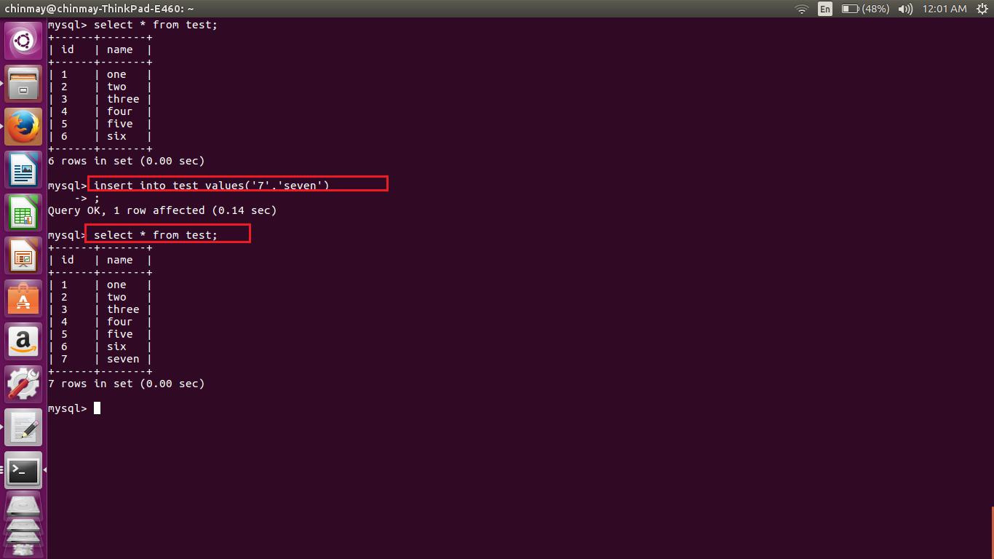

**Here we are inserting two more values into the same table ‘test’.**

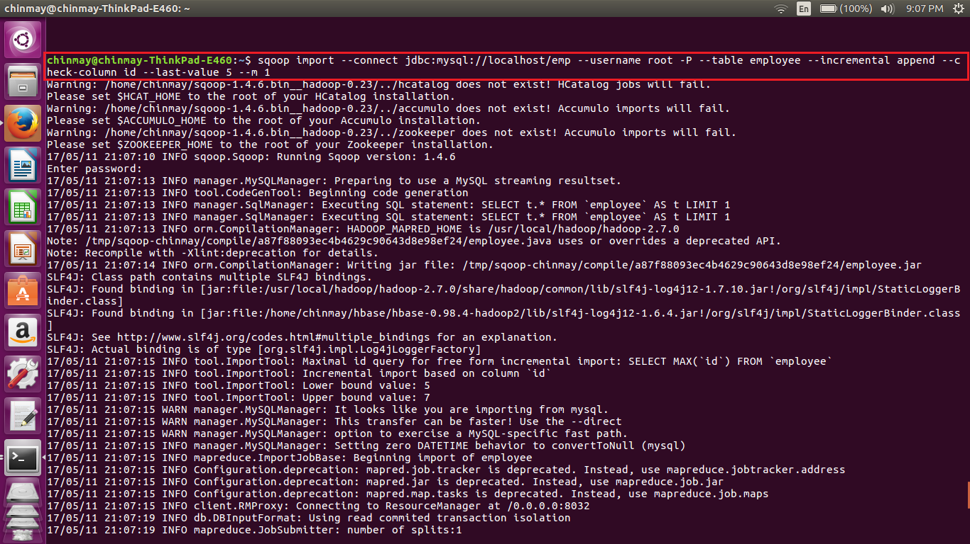

**Here again we are implementing a scoop job with incremental append. Where checking the last row a 5**

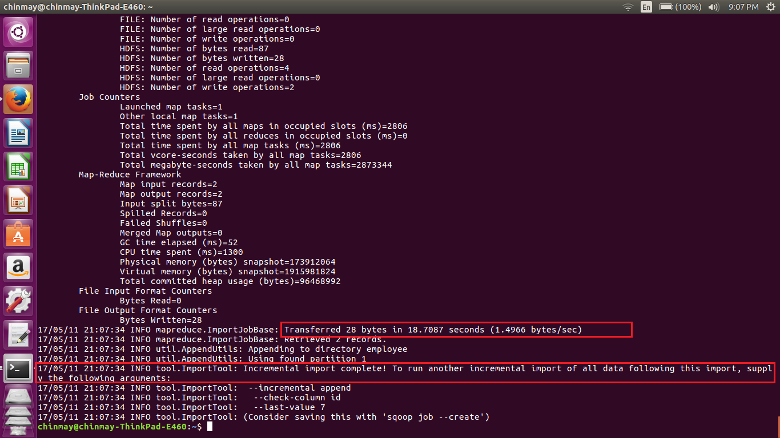

**Here we can see incremental import is complete.**

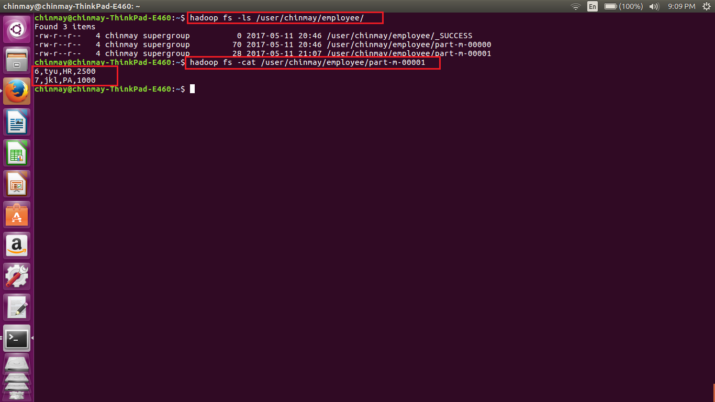

**Here we can see that a new map file has been created, where the next two additional values are added.**